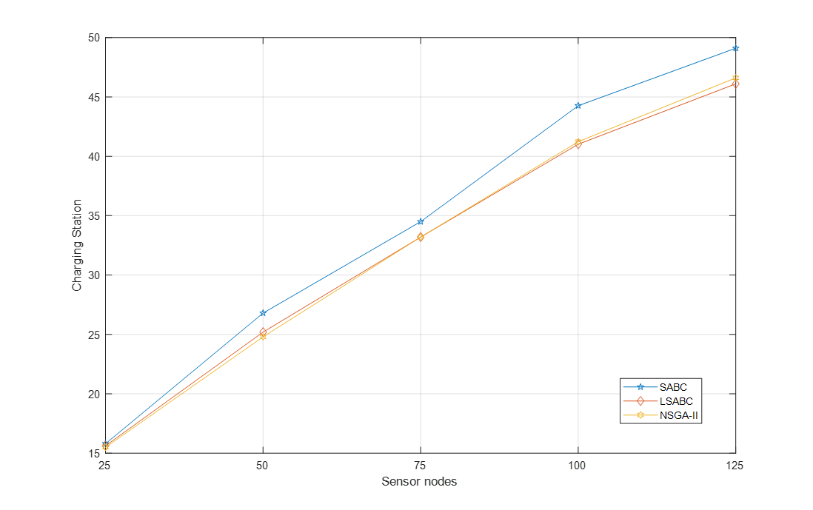

Figure 14. The number of charging station with sensor nodes increasing from 25 to 125